|  |  |  |  |  |
| --- | --- | --- | --- | --- |
| **INTERSTATE CONTAINER CORPORATION** | | | ***Date:* 10/20/2014** | ***Spec #:*** |
| ***Customer:*** | **DeMet's Candy** |  |  |  |
| ***Description:*** | **RSC.612/0** |  |  |  |
| ***Style:* RSC** |  | ***Revision Info:* [0] 10/20/2014:** |  |  |
| ***I.D. :* 9+11/16 x 7+9/16 x 14+1/4** | | ***Blank size:* 22+1/4 x 36+1/4** |  |  |
| ***Board:* 32 B K** |  | ***Combination:* 35HP - 23M - 35HP** | ***Designer:* Brian Romankow** | |

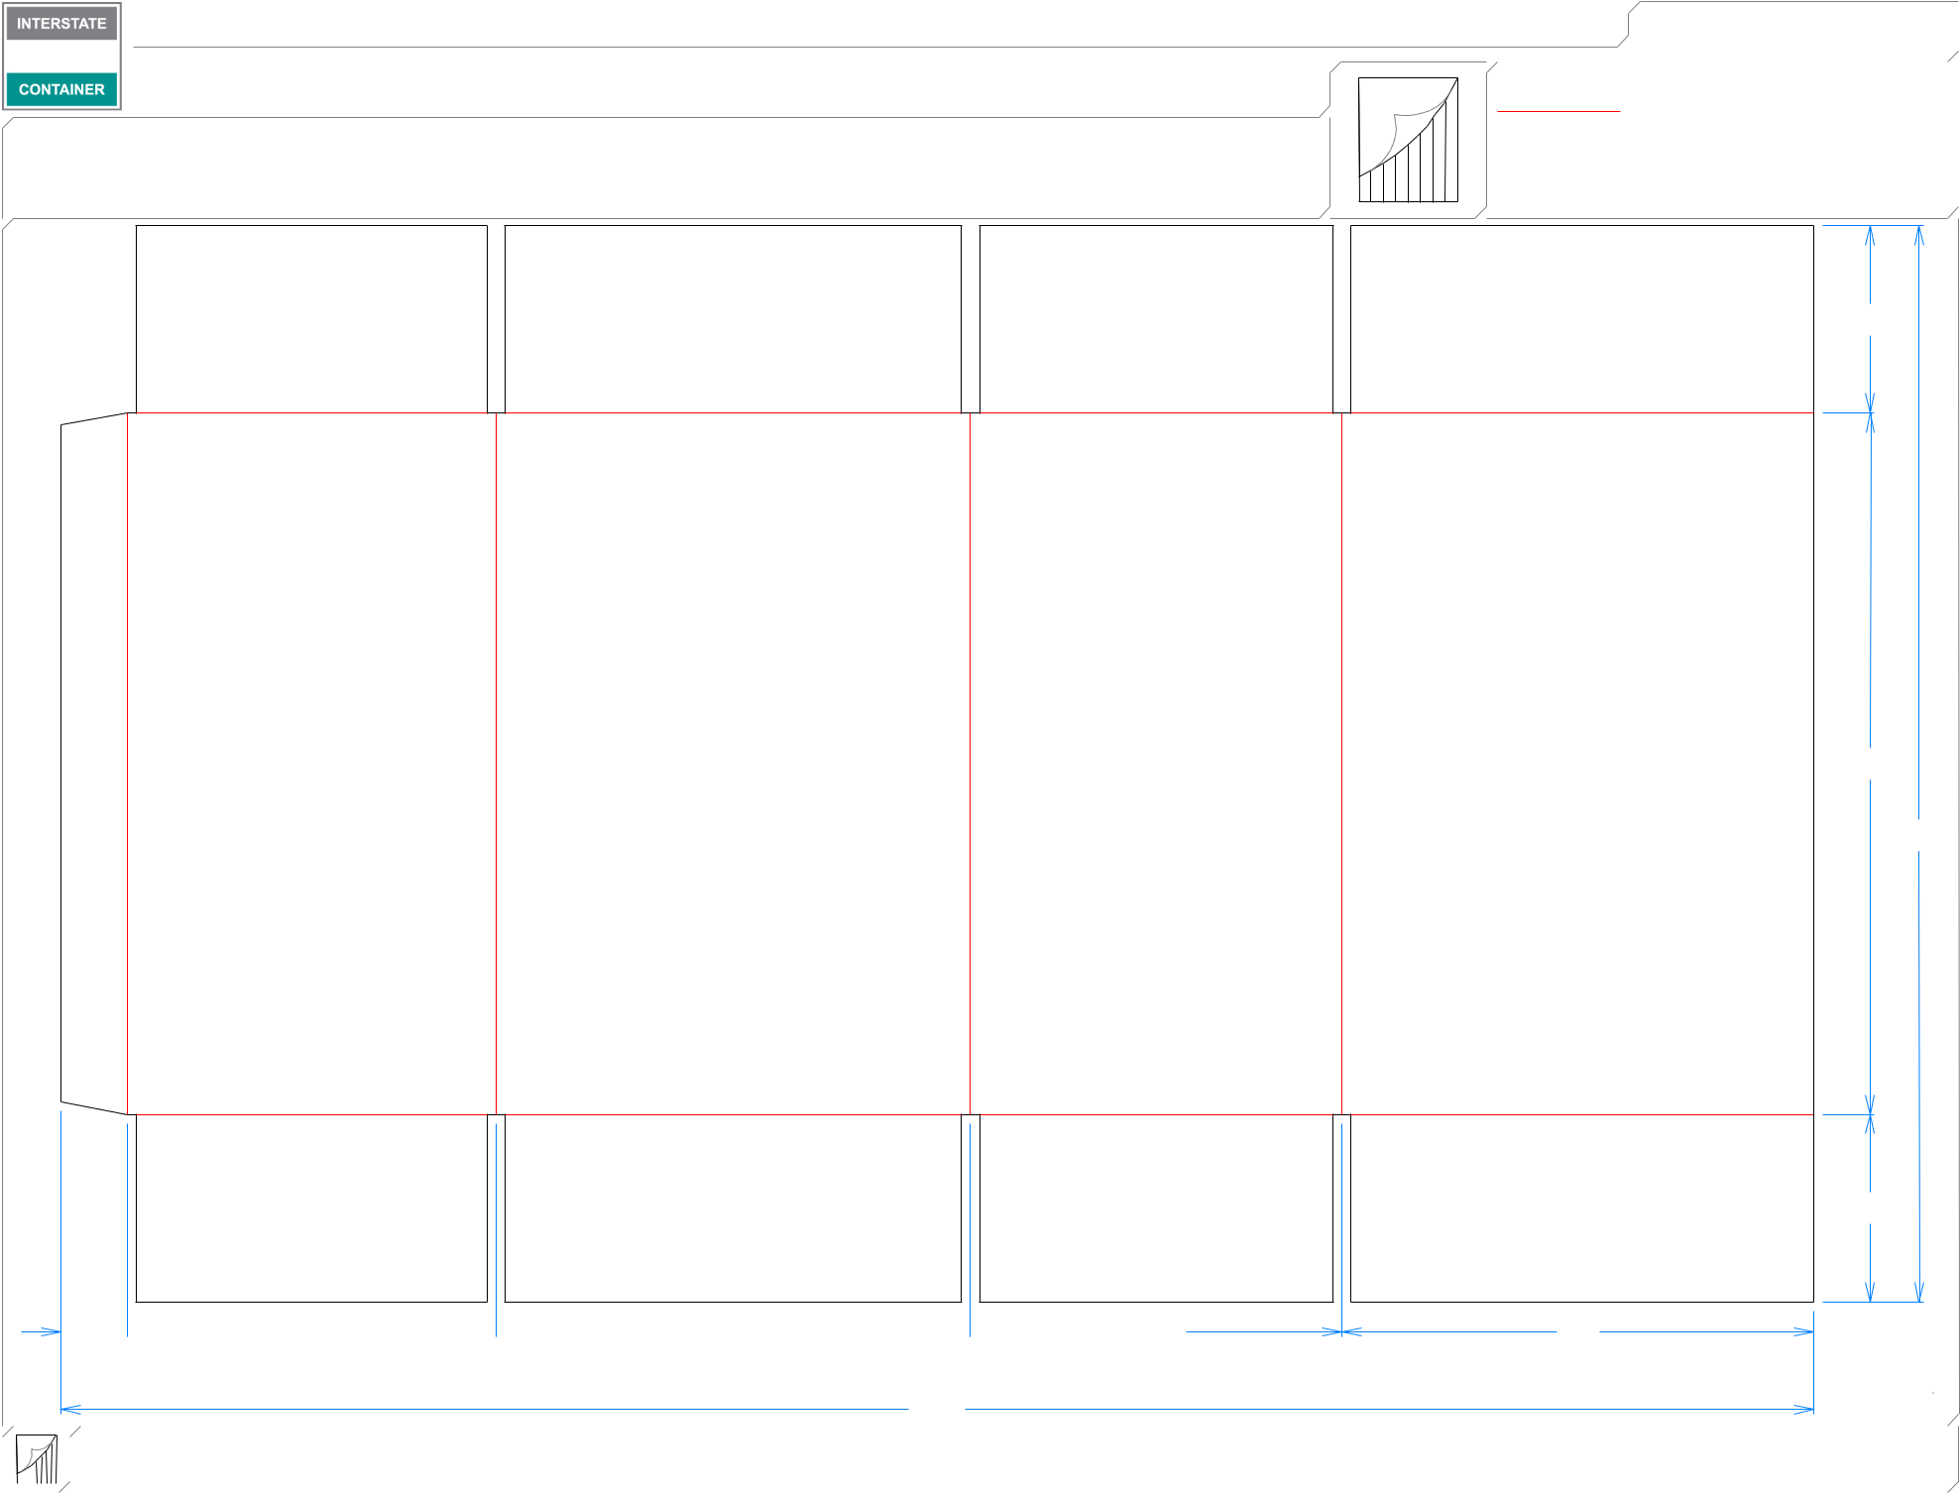

13*/*8  75*/*8  913*/*16  711*/*16

|  |  |  |  |  |
| --- | --- | --- | --- | --- |
| ***Design #:*** | | **141213-01** |  |  |
|  |  |  |
|  |  |  |  |  |
|  | ***Cut*** | **164 in.** | |  |
|  |  |
|  | ***Crease*** | **126 in.** | |  |
|  |  |  |  |  |

37*/*8

141*/*2

221*/*4

37*/*8

93*/*4

361*/*4

|  |  |  |  |  |  |  |  |  |  |  |
| --- | --- | --- | --- | --- | --- | --- | --- | --- | --- | --- |
|  |  |  |  |  |  |  |  |  |  |  |
|  |  |  |  | **inside view** | | ***notes:*** |  |  |  |  |
|  |  |  |  |  |  |  |  |
|  |  |  |  | **Vertical Corrugation** | | ***Qty/unit:*** | ***Area - waste:* 5.45 sq. ft** | ***Waste on blank:* 2.6%** | ***Piece weight - waste:* 0.56 lbs./255.11 g** |  |
|  |  |  |  |  |
|  |  |  |  |  |